Name _____________________________________________________________________________
-et word family
Directions: Choose a net. Color it appropriately. Write the word for the picture that is on the net. All words will end with -et.

- 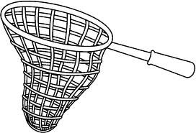 __________________________ 4. ___________________________

- __________________________ 5. ___________________________

- __________________________ 6. ___________________________

Choose 1 –et word and write a sentence.
__________________________________________________________________________________
__________________________________________________________________________________

